Keywords:
Saccade:
Movement of the eye from one point to another, either horizontally or vertically.
Saccade Amplitude
Size of saccade measured in degrees or minutes of arc. Actual Saccade/Desired Saccade is the accuracy of the saccade (also called gain) and is too small if <1 and too big if >1.

Gaze Data Paper

Peak Velocity
Highest velocity reached by a saccade

Duration
Time of completion of a saccade, usually in tens of milliseconds.

Latency
This is time between appearance of a target and the beginning of a saccade.
Saccade Amplitude, duration and peak velocities (velocity) are naturally closely related and dependent on each other. The ‘normality’ of eye movement can be predetermined from the relationship of the three which for amplitude and duration is for normal subjects linear when plotted. The linear line equation is 2.2 * Amplitude + 21.

Smooth Pursuit
Two phases, Initiation and Maintenance of eye motion.

Initial acceleration
Rate of change in eye velocity. About first 20ms fairly consistent irrespective of target but next 80ms is affected by target. After about that pursuit is not open-loop anymore as visual feedback will then be available.

Peak Velocity
Highest velocity of eye motion during pursuit. Peak Velocity/Target Velocity is accuracy of Smooth Pursuit (gain).
Velocity set at time points
Velocity measured at particular times in relation to target or pursuit initiation can sometimes be preferable to Peak Velocity.

Latency
Time between appearance of target and beginning of pursuit.
- Aim of study is to study identifying of individuals based on their reading characteristics.
- Existing Models use simple aggregate features of movement or parametric density models to calculate measures like saccade velocity, amplitude, etc.
- Parametric densities calculated with a Gaussian process.

Introduction
Cognitive psychology involves studying the relationship between vision, cognition and motor control during reading. Eye movement is enough to identify a user when routinely accessing a document without any set protocol. Here if individual does not generate expected (observed) eye movement then additional verification is required for their identification. In cases where artificial stimulus is used, aggregated values of the eye movement features or aspect-capturing of eye movement distributions (word fixation duration. Saccade between words, peak velocity, etc) is better for differentiating individuals. Some of these distributions need to be estimated from very few observations, hence a key challenge is to design models that are flexible enough to capture characteristic differences between readers and yet robust enough to handle sparse data (I assume we will be using artificial stimulus in this paper).
This paper uses flexible semi-parametric density models. They placed a Gaussian process prior over densities that concentrate probability mass on densities that are close to the gamma family. A posterior distribution over densities is derived.
With sparse data – posterior will still be sharply peaked around distributions in gamma family reducing capacity of model and overfitting.
With enough data - the model will deviate from the gamma centred prior when enough data is +available.

Problem Setting
R readers {1…..R}, X Texts {1…….X}, Eye movement patterns on X by reader r {S₁^{(r)}…….S_{n}^{(r)}} and p(S|X_{i},r,T) is a user-specific distribution over eye movement patterns given a text X_{i}. T is a true but unknown model that defines all reader-specific distributions. T is assumed to be able to be partially derived for each reader such that p(S|X_{i},r,T) = p(S|X_{i},r,Y_{r}) where T = (Y_{1………….}Y_{r}). Observations of all readers is aggregated into a variable S^{(1:R)}= S⁽¹⁾…………..S^{(R)}). P(T) = π_{r=1}^{R}p(Y_{r}).
At test time, a new set of eye movement patterns S’ is observed from an unknown reader on a new set of texts X’ (test data). All users are equally likely to be observed at test time and the goal is to infer the most likely reader to have generated the new eye movement patterns S’. In a Bayesian setting:
A - r* = arg max p(r|X’,S’,X,S^{(1:R)}), it can be rewritten as below:
B - = arg max ∫ p(S’|r,X’,T)p(T|X,S^{(1:R)})dT
C - = arg max ∫ p(S’|X’,Y_{r})p(Y_{r}|X,S^{(r)})d_{Yr}, where p(S’|X’,Y_{r}) = π p(S_{i}’|X_{i}’,Y_{r}) and p(Y_{r}|X,S^{(r)}) α p(Y_{r}) π p(S_{i}^{(r)}|X_{i},Y_{r}).

Probabilistic Model
Yϵ {Y₁,…..,Y_{R}} is user-specific model, X ϵ X is a text, S = ((s₁,d₁),…..(s_{T},d_{T})) is an eye movement, gaze fixation sequence consisting of fixation position s and fixation duration d ϵ R.
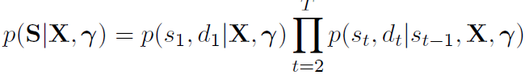Ỽ
4 saccade types in psychological literature: Refixation on current word, Next word movement to next word, Forward Skip to skip one or more words to next fixated word and Regression which is going back to a word from earlier.
Each saccade type’s distribution relationship with Gamma distributions over Fixation duration and saccade amplitude shown below
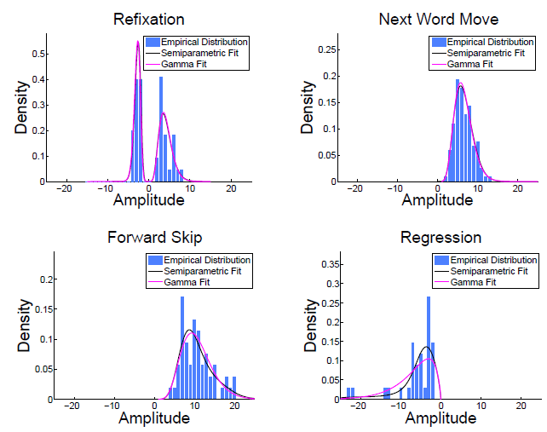
So, likelihood of Gaze fixation sequence given most previous position, 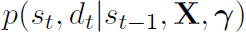, is as follows: At time t, model draws a saccade u_{t} (from the 4) and then draws a saccade amplitude a_{t} fixation duration d from type specific distributions 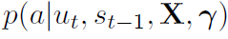 and 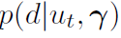. New fixation position s_{t} = s_{t-1} + a_{t}. Distribution over saccade types is multinomial and distribution over amplitude and duration are semi-parametrically modelled as discussed below.

Model of Saccade Amplitude
Probability model (likelihood) for amplitude is 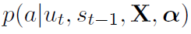. Distribution over amplitude for all 4 saccade types is 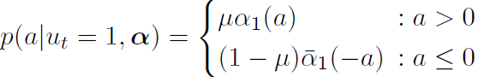 where µ is a mixture weight and α₁, α₁’are positive and negative distribution densities for Refixation. 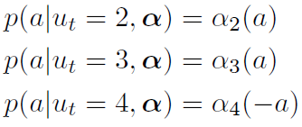 α₂, α₃ and α₄ are amplitude distribution densities for the other three saccade types. 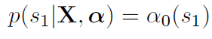 α₀ is distribution over initial fixation position of Refixation. . They are all aggregated into one model component α.
Minimum and Maximum distance constraints on Amplitude 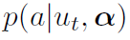 determine likelihood of amplitude 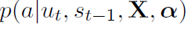. A minimum and maximum distance constraints determine saccade type and transforms normal saccade amplitude distribution into amplitude likelihood.
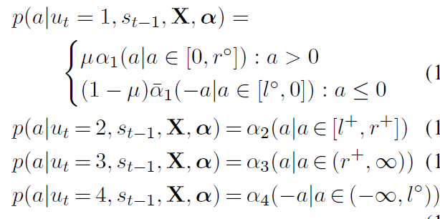

Model of Fixation Duration
and for initial fixation duration 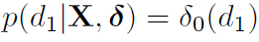 and δ0,…..,δ₄ are aggregated into one model component δ.
With this, p(S|X,Y) is completel.

Prior Distributions
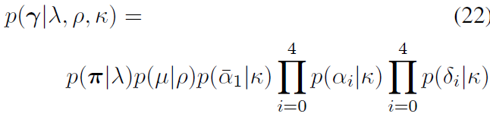 Challenge here is to develop appropriate prior for distribution densities of fixation duration and amplitude. Since both distributions are close to gamma distribution, their priors are defined over densities that concentrate probability mass around the gamma family.

Empirical Study
251 individuals, 144 sentences

AN Empirical study on the patterns of eye movement during summarization tasks

Abstract
Focus is study position of eyes in texts on images with more emphasis believed to be on key parts of said texts/ images. Eye movements of 10 programmers used while programming.

Introduction
- Reading computer programs uses different patterns from reading normal text.
- Programmers usually skim through text during summarization. What are they skipping then? Knowing this will improve program summarization.
- Aim here is to study eye movement patterns between different sections of a code.
- “Eye movement pattern from eye tracking data”
- Patterns were found to be consistent among programmers and between program methods.

The Problem
- Program reading order un-researched, reading speed unknown, reading direction unknown
- How does personal reading habits affect code reading patterns for summaeization?

Background and Related Work
- Reading behavior on natural text is different from source code (more skimming here and code has more strict structures)
- This paper aims to check for any correlations for natural text reading when programmers read source code
Lohse and Peltz
Fixation – No movement for at least 100ms. Smaller ads and those lower on pages were largely ignored.
Experiment Set up - Tracking eye movement between ‘Keywords’ in different parts of methods and summarized each method after.
Fig 1a Example:
- Keyword transition (saccade) usually within two words (indicates beginning of qualitative analysis)
- Usually no return sweeps (indicating skimming)
- No obvious reading pattern (suggesting again skimming)

Qualitative study design
Methodology – Sketching out a user’s eye movement on paper to analyse reading habit.

Qualitative study results
- Readers read text similarly to natural language text (many important entities in programming originate from the left), equal amount of top-bottom and bottom-top reading patterns
- Programmers do more skimming than reading
- Disorderly scanning over orderly, sectional scanning
- Similarity in reading behavior among programmers

Quantitative study design
Same reader changing reading habit for different text could indicate similarity can’t be drawn between different readers reading patterns as the text itself (understanding of it, search for meaning in it) could have a bigger influence.
Methodology
Take orders of eye movements of different readers for different texts and compute similarity between them.
- Each movement direction (pattern) is given a value. (How much do they prefer reading like natural language text)
- Saccade speed/peak used to determine skimming or thorough reading. (How often do they prefer skimming)
- Created a mapping of ‘jumps’ between sections. (how often do they jump between sections)
- Used the above for drawing comparisons between readers.

Statistical Tests
- Wilcoxon signed-rank test used. Suitable because reading pattern for each method are compared for user pairs and data may not be normally distributed.
- One-way ANOVA used to determine similarities between reading patterns. It is suitable because texts used were similar in size and type but different.

Quantitative study results
- Statistically, readers read code like natural language text equally as much as they do not
- More skimming than reading with no fixed reading pattern
- Null Hypothesis rejected. Readers do read in similar pattern

Gaze Columns

Hypothesis
“Detect/Differentiate between Reading, Scanning and Skimming to further understand a user’s information search.”
- Null Hypothesis – The subjects follow a similar reading pattern. We can test for variances
- in their reading behavior (direction, speed, saccade amplitude) to prove or disprove their differences.
- If there’s a way to link reading behavior to level of understanding (through subject feedback, if it exists), a null hypothesis could be that there is a link between reading pattern and level of understanding. We can then try to disprove it.
Comments: Without real knowledge of the subjects and the text they read (experiment conditions), there are limitations to possible hypothesis.

Related Project
Abstract: Location based visual characteristics on web pages during searches
Prediction of visual attention web page elements may/will receive
A new method for mapping gaze data to visual scenes

ADCpx – on the screen
MCSpx – on the media

Data Observations
Only one value in ‘StudioProjectName’ column
Media width (1920 px) and Media height (1200 px) suggest the media covered the whole screen, 1920 * 1200 (RecordingResolution). Also MediaPosX and MediaPosY also suggest it.
Also MouseEvents X and Y on screen (ADCpx) are equal to MouseEvents (MCpx) X and Y on media.

Studio Event – Scanning, Skimming, Reading,etc

Media data recorded only when Fixation data recorded

FixationPoint(MCSpx) and GazePoint(MCSpx) only recorded at same time. Perhaps data where these columns are empty are when subject is not looking at the screen.

pb1.drop(columns=['ExportDate','StudioVersionRec','StudioProjectName','RecordingName','RecordingDate','RecordingResolution','PresentationSequence','FixationFilter','MediaName','MediaPosX (ADCSpx)'],inplace=True)
pb1.drop(columns=['StudioTestName','MediaPosY (ADCSpx)','MediaWidth', 'MediaHeight', 'SegmentName','SegmentStart', 'SegmentEnd', 'SegmentDuration', 'SceneName','SceneSegmentStart', 'SceneSegmentEnd', 'SceneSegmentDuration','LocalTimeStamp','MouseEventX (ADCSpx)','MouseEvent','MouseEventY (ADCSpx)'],inplace=True)
pb1.drop(columns=['KeyPressEvent','StudioEventData','ExternalEventIndex', 'ExternalEvent', 'ExternalEventValue','EventMarkerValue','GazePointLeftX (ADCSpx)', 'GazePointLeftY (ADCSpx)','GazePointRightX (ADCSpx)', 'GazePointRightY (ADCSpx)','GazePointX (ADCSpx)', 'GazePointY (ADCSpx)','GazePointLeftX (ADCSmm)','GazePointLeftY (ADCSmm)', 'GazePointRightX (ADCSmm)','GazePointRightY (ADCSmm)','StrictAverageGazePointX (ADCSmm)','StrictAverageGazePointY (ADCSmm)', 'EyePosLeftX (ADCSmm)','EyePosLeftY (ADCSmm)', 'EyePosLeftZ (ADCSmm)', 'EyePosRightX (ADCSmm)','EyePosRightY (ADCSmm)', 'EyePosRightZ (ADCSmm)','CamLeftX','CamLeftY', 'CamRightX', 'CamRightY', 'DistanceLeft', 'DistanceRight','IRMarkerCount', 'IRMarkerID', 'PupilGlassesRight', 'Unnamed: 85'],inplace=True)

excel_file = pd.ExcelWriter('Proband_1.xlsx')
pb1.to_excel(excel_file, sheet_name='Band1', index=False)
excel_file.save()
excel_file.close()

To be included?
MediaHeight
MediaWidth

- Exponential and gamma distribution ,study and plot these graphs for pupil size - (Madhu\TJ) 22 April.

Distribution Test

Anderson Darling
For both Exponential and Normal tests the same significant boundaries are recommended as shown below. If the corresponding statistical values are not at least equal to the critical values then the data is considered not to fit a Normal or Exponential distribution.
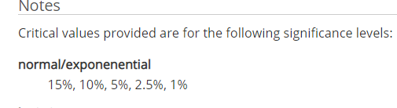
An average of the size of both Left and Right pupils are taken for each record and tested for distribution type (Exponential and Normal).

Normal Test
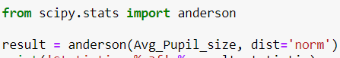
The ‘scipy.stats’ class ‘anderson’, is used to carry out the test.
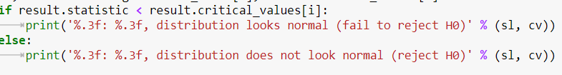
As seen above, the calculated statistic from our data is compared to the Critical Values of the data and based on that the H0 is either rejected or not. And below is the result for Normal Distribution test:
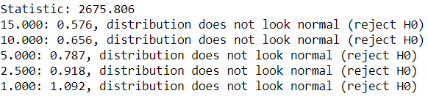
To further solidify that finding, below is a Histogram plot of the data and it is clear it doesn’t look Normally Distributed.
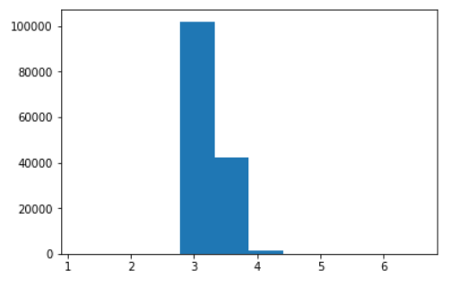

Exponential Distribution Test
As shown below, the Exponential distribution is chosen to be tested against:
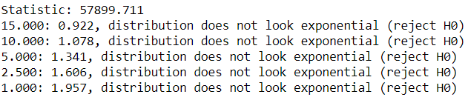
The distribution is also not an exponential distribution.

Quantile-Quantile Normality Test
This class takes the entire data and distributes it normally. Then it compares each data instance to it’s corresponding ideal value. The two distributions (ideal and actual) are then visualized in a simple plot. With the ideal distribution plotted on a straight line, we can see if the actual distribution diverges from it as it is plotted around it with scatter dots.
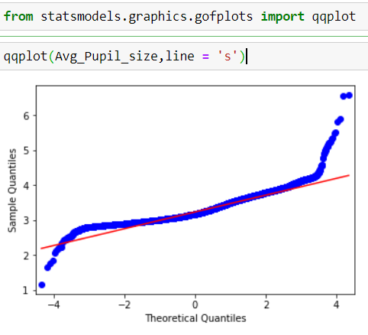
As can be see above, the actual distribution (in blue) diverges greatly from the ideal Normal distribution (in red). This clearly indicates that the Pupil Size data is not evenly distributed.

https://www.liverpool.ac.uk/~pcknox/teaching/Eymovs/params.htm

